**Java Package:**

A java package is a group of similar types of classes, interfaces and sub-packages.

Package in java can be categorized in two form, built-in package and user-defined package.

There are many built-in packages such as java, lang, awt, javax, swing, net, io, util, sql etc.

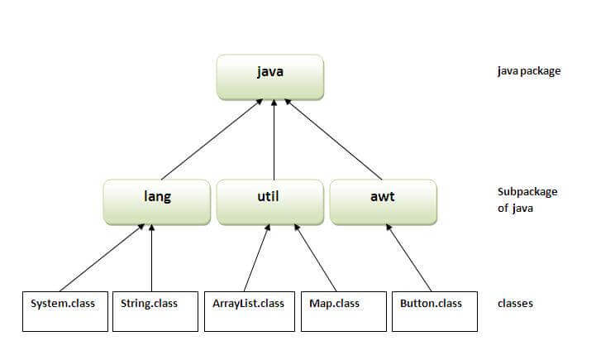

**How to access package from another package? :**

There are three ways to access the package from outside the package.

import package.*;

import package.classname;

fully qualified name.

1. **Using packagename.\***

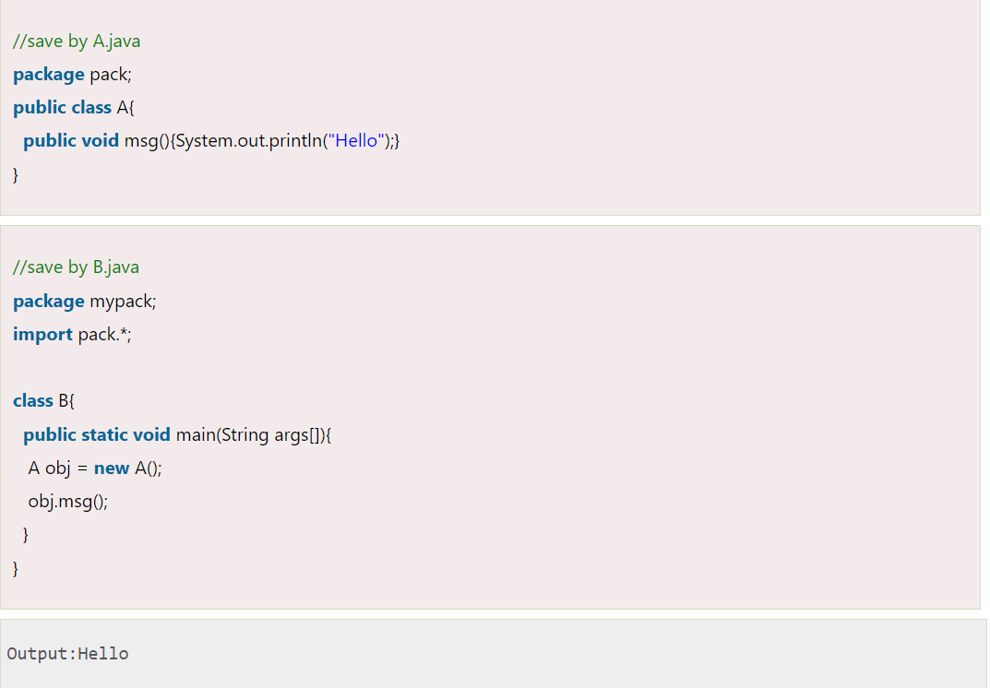

1. **Using packagename.classname:**

**3) Using fully qualified name**:

**Note: If you import a package, subpackages will not be imported :** If you import a package, all the classes and interface of that package will be imported excluding the classes and interfaces of the subpackages. Hence, you need to import the subpackage as well.

**Note:** The standard of defining package is domain.company.package e.g. com.javatpoint.bean or org.sssit.dao.

**Example of Subpackage :**

